Car Sales Analysis | overview

# Project Overview

The Car Sales Data Analysis project aims to provide insight into car sales trends, customer demographics, and dealer performance using historical sales data. This project involves cleaning, processing, and analyzing the data to derive meaningful patterns and insight that can inform business decisions.

# Objectives

1. **Analysis Sales Trends:** Understand how car sales vary over time and identify any seasonal pattern.
2. **Customer Demographics:** Examine the demographics of customers, including gender and income distribution.
3. **Dealer Performance:** Evaluate the performance of different dealers based on sales volume and revenue.
4. **Car Model Popularity:** Identify the most popular car models and brands.
5. **Regional Analysis:** Assess sales performance across different regions.

# Data Sources

1. Car Sales Data CSV: Contains information about car sales, including customer details, dealer, information, and car specifications.
2. Tableau File :Contains Visualizations and reports created using Tableau analyze the car sales data.

Data Description Data Rows:

Data Column:

The project is sub-divided following sections. These are:

1. Load the data from CSV and Tableau files.
2. Summarization of Data to understand Datasets.
3. Year-to-Date (YTD) Total Sales
4. Year-over-Year (YOY) Growth in Total Sales
5. YTD Average Price
6. YOY Growth in Average Price
7. YTD Cars Sold
8. YOY Growth in Cars Sold
9. Visualization of Data to understand Dataset (Plots, Graphs etc.)
10. Line chart
11. Pie chart
12. Donut Chart
13. Geographically
14. Tabular grid







Visualization:

# 1. Year-to-Date (YTD) Sales Weekly Trend Analysis.

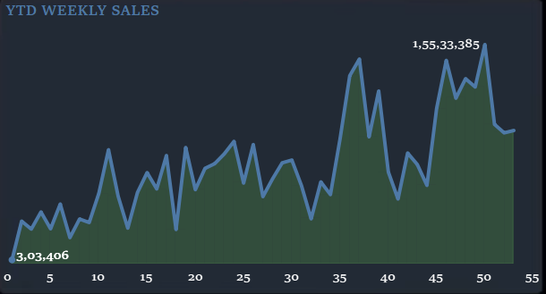

**Overview:**

The Year-to-Date (YTD) sales weekly trend analysis tracks the cumulative sales from the beginning of the year to the current date on a weekly basis. This analysis helps identify sales patterns, highlight seasonal variations, and gauge overall performance throughout the year.

# Key Insights

1. **Consistent Growth**: The YTD sales show a consistent upward trend, indicating steady growth in car sales over the weeks.
2. **Seasonal Peaks**: Notable spikes in sales are observed during specific weeks, likely corresponding to promotional events or seasonal demand increases.

These insights provide valuable information for planning inventory, marketing strategies, and sales targets.

**2.YTD Total Sales by Body Style**

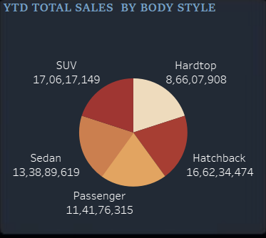

# Overview

The Year-to-Date (YTD) total sales analysis by body style provides insight into the popularity and performance of different car body styles. This analysis helps in understanding customer preferences and market trends for various body types.

# Key Insights

1. **SUV Dominance**: SUVs lead in total sales, reflecting a strong customer preference for this versatile and popular body style.
2. **Hatchbacks and Sedans**: Hatchbacks and sedans also show significant sales figures, indicating their continued relevance and demand in the market.

These insights assist manufacturers and dealers in making informed decisions regarding inventory management and marketing strategies.

**3.YTD Total Sales by Color**

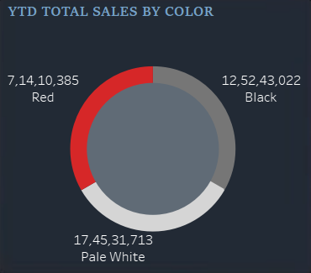

# Overview

The Year-to-Date (YTD) total sales by color analysis reveals customer preferences for car colors, helping manufacturers and dealers tailor their inventory and marketing strategies to meet demand.

# Key Insights

1. **Popular Colors**: Black, white, and red are the top-selling car colors, indicating a strong preference for these classic and vibrant choices.
2. **Color Trends**: The consistent sales across these colors highlight their broad appeal and popularity among customers.

These insights guide color-specific inventory decisions and promotional efforts.

**4.YTD Cars Sold by Dealer Region**

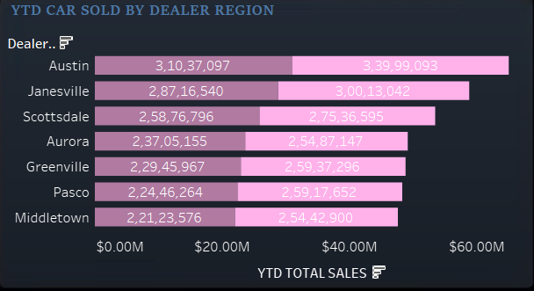

# Overview

The Year-to-Date (YTD) analysis of cars sold by dealer region highlights the geographic distribution of car sales, helping to understand regional market dynamics and dealer performance.

# Key Insights

1. **Top Regions**: Regions such as Middletown and Aurora lead in car sales, showcasing their strong market presence and customer base.
2. **Regional Variations**: Significant variations in sales across regions suggest differences in market demand and regional economic conditions.

These insights assist in regional strategy planning and resource allocation for maximizing sales performance.

**5.Company-Wise Sales Trend in Grid Form**

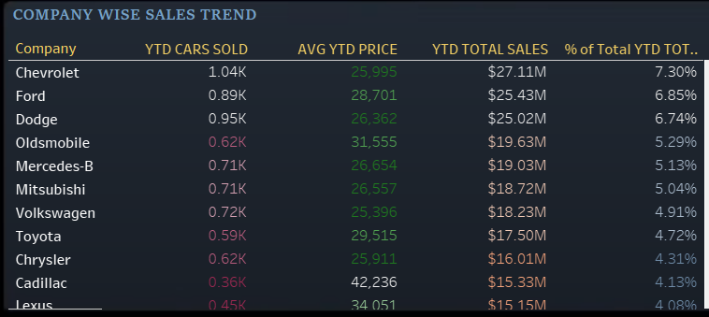

# Overview

# The Company-Wise Sales Trend analysis in a grid format presents a clear comparison of sales performance across different car manufacturers, providing insights into each company's market position.

# Key Insights

1. **Leading Companies**: Companies like Ford and Toyota show strong sales trends, reflecting their market strength and customer loyalty.
2. **Comparative Performance**: The grid format allows for easy comparison of sales figures, helping to identify both market leaders and areas for potential growth.

These insights support strategic decision-making and competitive analysis.

# Conclusion:

These insights collectively aid in understanding market dynamics, customer preferences, and regional performance, guiding strategic planning, inventory management, and marketing efforts to drive business growth and improve competitive positioning.